TITLE 92 - NEBRASKA DEPARTMENT OF EDUCATION
CHAPTER 86 - REGULATIONS AND PROCEDURES FOR PUBLIC SCHOOL BREAKFAST PROGRAM REIMBURSEMENT

NUMERICAL TABLE OF CONTENTS

STATUTORY CODE
SUBJECT AUTHORITY SECTION

General Provisions §§79-10,137 to 79-10,139 001

Definitions §§79-10,137 to 79-10,139 002

Reimbursement Procedures §§79-10,137 to 79-10,139 003

NDE Claim for Reimbursement Form NDE-28-036 Appendix A
with Instructions

TITLE 92 - NEBRASKA DEPARTMENT OF EDUCATION
CHAPTER 86 - REGULATIONS AND PROCEDURES FOR PUBLIC SCHOOL BREAKFAST PROGRAM REIMBURSEMENT

ALPHABETICAL TABLE OF CONTENTS

STATUTORY CODE
SUBJECT AUTHORITY SECTION

Definitions §§79-10,137 to 79-10,139 002

General Provisions §§79-10,137 to 79-10,139 001

Reimbursement Procedures §§79-10,137 to 79-10,139 003

NDE Claim for Reimbursement Form NDE-28-036 Appendix A
with Instructions

TITLE 92 - NEBRASKA DEPARTMENT OF EDUCATION
CHAPTER 86 - REGULATIONS AND PROCEDURES FOR PUBLIC SCHOOL BREAKFAST PROGRAM REIMBURSEMENT

001 General Provisions

001.01 Purpose. The Legislature has found that school breakfast and lunch program are integral parts of Nebraska’s educational system. Accordingly, the Legislature will reimburse each qualified public school in Nebraska a portion of the cost of such school’s school breakfast program.

001.02 Statutory Authority. This Chapter is adopted pursuant to Neb. Rev. Stat. Sections 79-10,137 through 79-10,139.

001.03 Coverage. This Chapter sets forth the breakfast reimbursement requirements for qualified public schools in Nebraska for payments pursuant to Neb. Rev. Stat. Section 79-10,138.

002 Definitions

002.01 Breakfast shall mean a meal which meets the nutritional requirements set out in either 7 CFR Part 220.8 or 7 CFR 220.8a, as indicated in the Program Application, and which is served to the school’s eligible students in the morning hours prior to the lunch meal, pursuant to the requirements of the School Breakfast Program at 7 CFR Part 220.

002.02 Department shall mean the Nebraska Department of Education.

002.03 Eligible student shall mean qualified public school students who participate in a school lunch program as authorized by the National School Lunch Act found at 42 U.S.C. 1751, et seq.

002.04 School lunch program shall mean the National School Lunch Program at 7 CFR Part 210, as authorized by the National School Lunch Act.

002.05 Qualified public school shall mean a Department accredited public school pursuant to Title 92, Nebraska Administrative Code, Chapter 10, (92 NAC 10), which operates a school lunch program as authorized by the National School Lunch Act.

002.06 State reimbursement shall mean the state funds payable to qualified public schools for breakfasts served to eligible students. The rate for breakfast reimbursement is 5¢ for each school breakfast served to each eligible student and payment is made for breakfasts served in the second preceding school year. Therefore, for example, payments made in 2007-08 would be for meal claims from 2005-06.

TITLE 92
CHAPTER 86

002.07 USDA shall mean the United States Department of Agriculture.

003 Reimbursement Procedures

003.01 Program and Site Applications on File. Each qualified public school that operates a school lunch program shall submit a completed Program Application and Site Application for each participating site to the Department. Forms are NDE-01-014 is available online from the Department and must be submitted online.

003.02 Breakfast Requirements. Only breakfasts which meet the USDA regulatory requirements at 7 CFR Part 220, and are eligible for federal reimbursement according to the National School Lunch Act, shall be eligible for state reimbursement.

003.03 Claim Deadlines Procedures. In order for the monthly reimbursement claim to be paid in a timely manner, the claim shall be submitted to the Department by the 5th day of the next month following the claiming month. Claims shall be made on the Department’s Claim for Reimbursement Form 28-036 (Appendix A) as revised April 2000. All claims shall be submitted to the Department within sixty (60) days of the close of the claiming month. Claims submitted later than sixty (60) days after the close of the claiming month shall not be payable. Claims shall be made on the Department’s Claim for Reimbursement Form NDE-28-036 (Appendix A), or the same Claim information may be submitted in the Nebraska Nutrition Services web-based reporting system. All claims submitted to the Department after the claim deadline of sixty (60) days past the last day of each month shall not be payable. For purposes of school breakfast reimbursement, the instructions in Appendix A attached to Claim for Reimbursement Form NDE-28-036 must be followed for all claims submitted to the Department pursuant to this Chapter, and such instructions are incorporated into this section by reference as if fully set forth herein.

TITLE 92 APPENDIX A
CHAPTER 86 Page 1 of 1
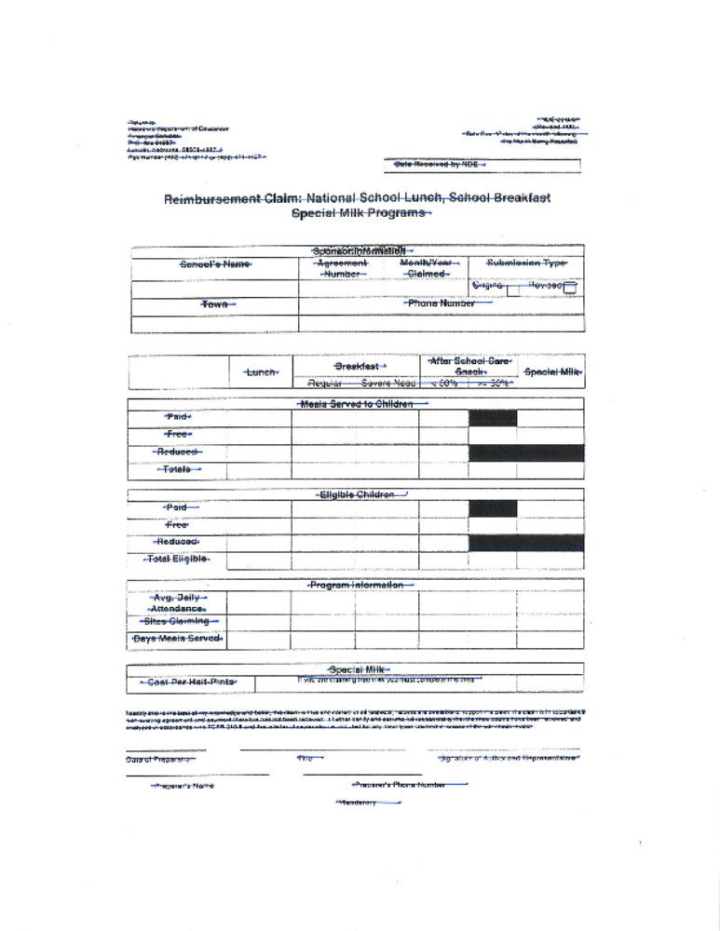

TITLE 92 APPENDIX A
CHAPTER 86 Page 1 of 2
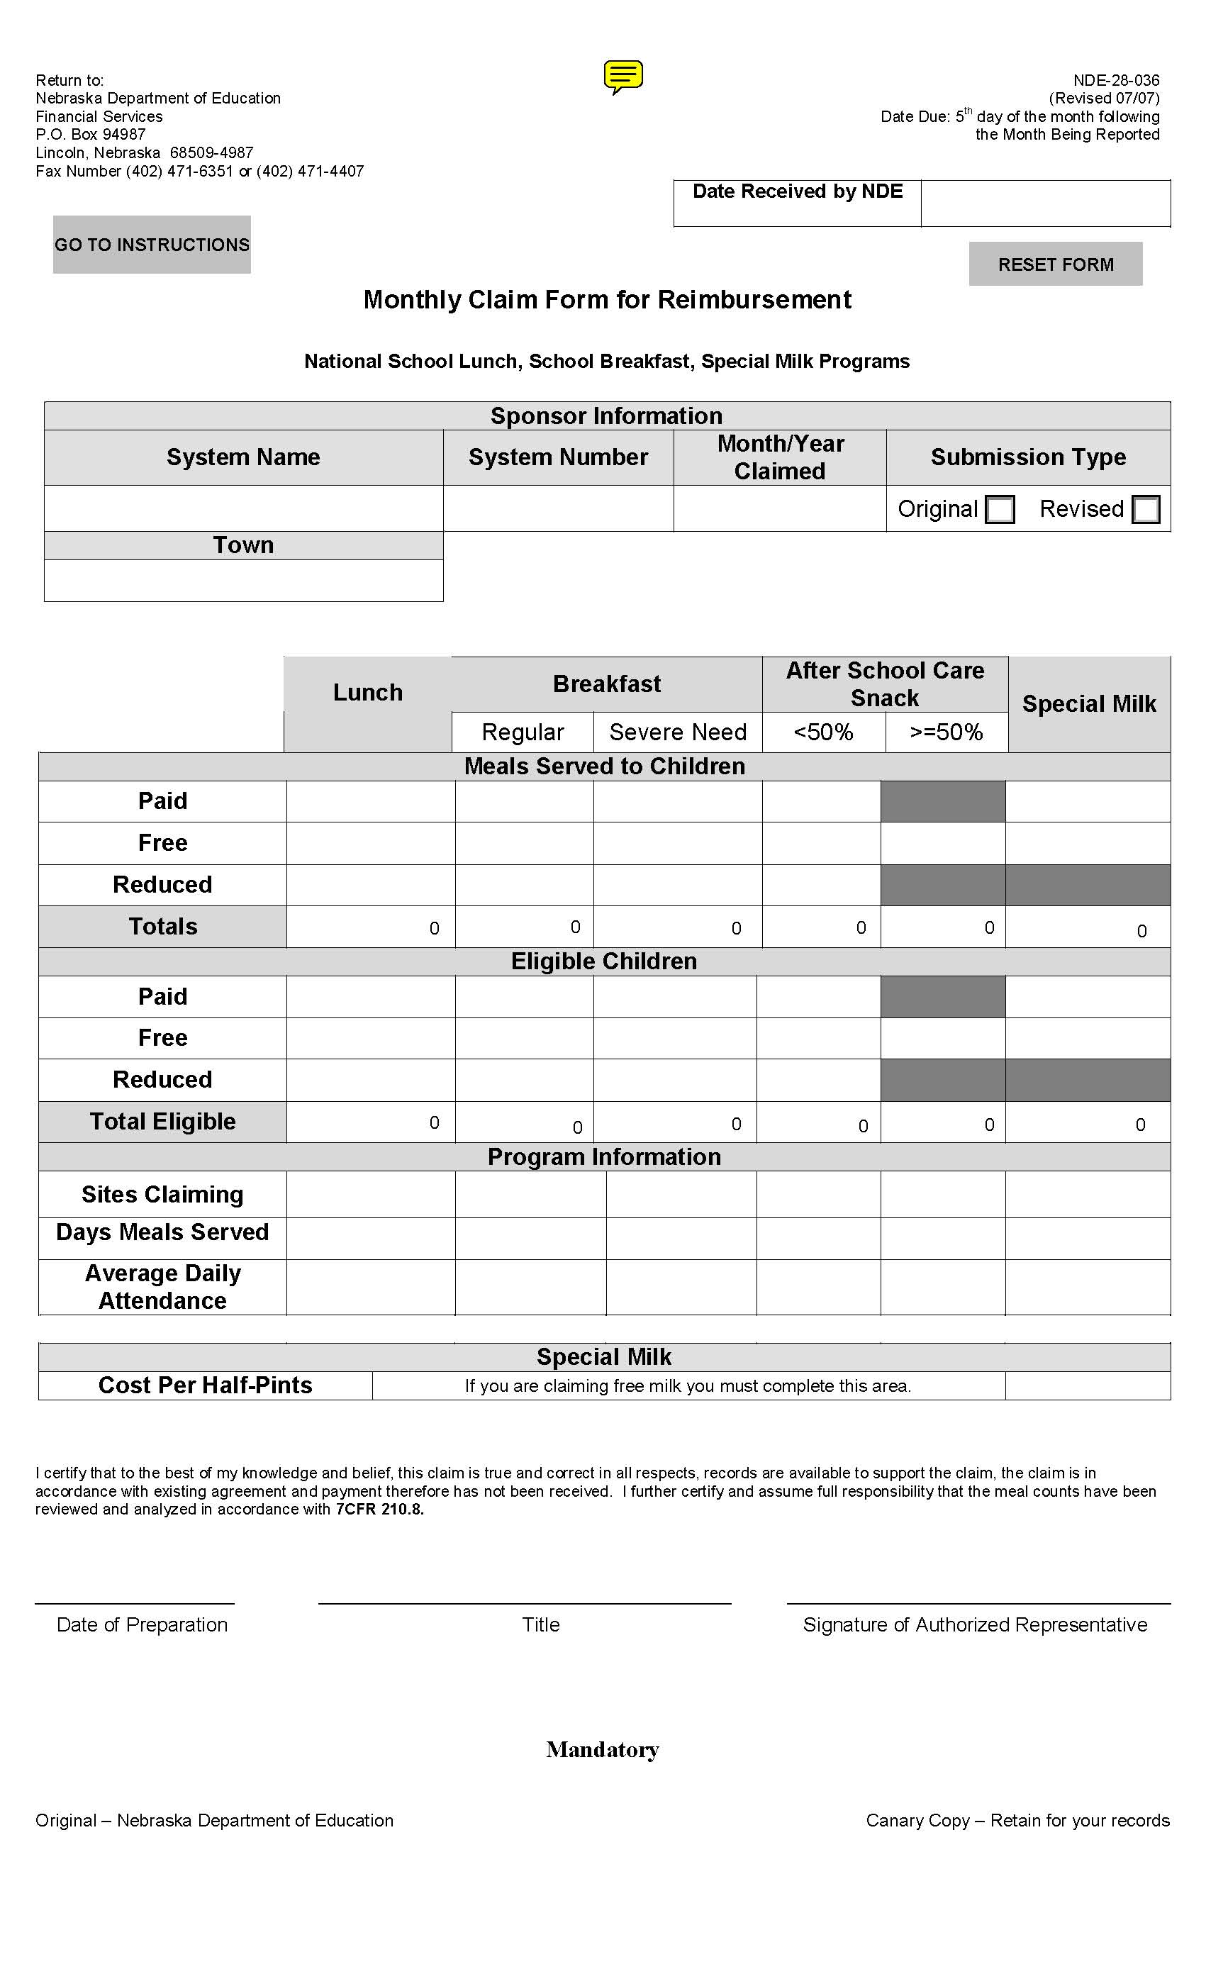

TITLE 92 APPENDIX A
CHAPTER 86 Page 2 of 2



